KADAPAKKAM (Uluru) COASTAL ENVIRONMENT CENTRE
PITCHANDIKULAM FOREST
P.0 AUROVILLE TAMIL NADU 605 101, INDIA.
Phone - 0413-2622365 431, Mobile-94433622246.
www.pitchandikulamforest.org
joss@auroville.org.in

Education is the key to creating interest in and awareness of our environment and of the need to conserve nature. We wish to set up education centres of excellence with effective environmental education programs which can be seen, felt and understood by all.

Title: Development of a Coastal Environment Education Centre at Kadapakkam

Duration: Three years

Introduction: This project is to develop the environment education programmes started by Pitchandikulam Forest, Auroville at the Nadukuppam High School, the Adyar Poonga in Chennai and the Kadapakkam (Uluru) Coastal Environment Centre. It aims to incorporate the environments of Forest, Farm, City and Coast into a sharing educational experience with a strong scientific base.
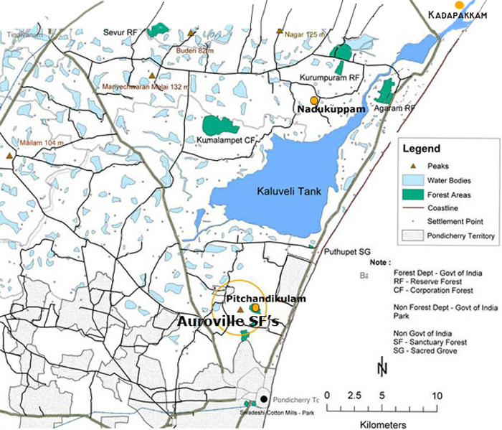

The Kadapakkam (Uluru) Environment Education Centre
An Environment Education facility has been established on the banks of the estuary where Kaluveli wetland joins the sea, in the Chittamoor taluk of the Kanjeevaram district of Tamil Nadu in southern India, about 50 kms from the city of Pondicherry. The site belongs to the Uluru Children’s Home, an orphanage built and run by the East-West Foundation of India. There is a large patch of degraded Forest Department land adjacent to the site which is to be developed in collaboration with the Department and the local community. The area has three habitats, seashore, estuary, and coastal forest, which makes the location ideal for such a centre with an associated environmental education camp site. Nearby are the remains of a 500-year-old structure, the Alamparai Fort.

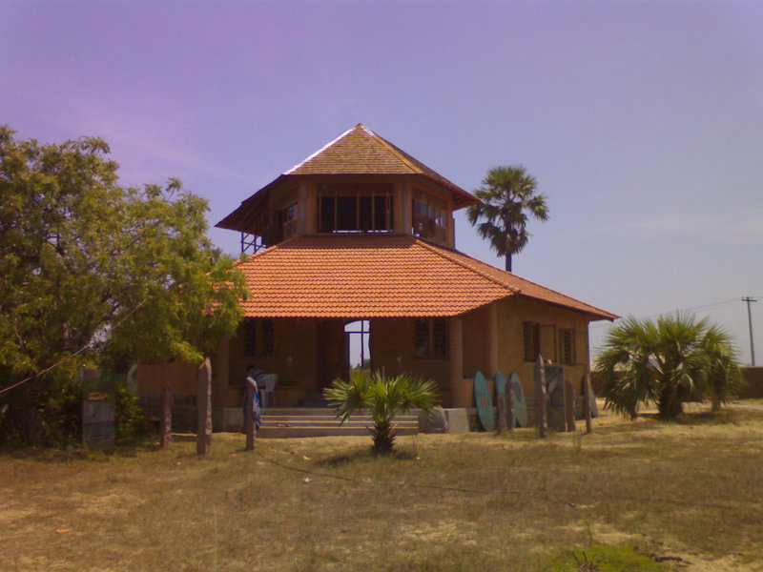

The centre, built with stabilized mud blocks, has a spacious circular ground floor and a much smaller upper floor with windows all around, affording a magnificent view of the surrounding land, including the canal, seashore, forest and the fort in the distance.
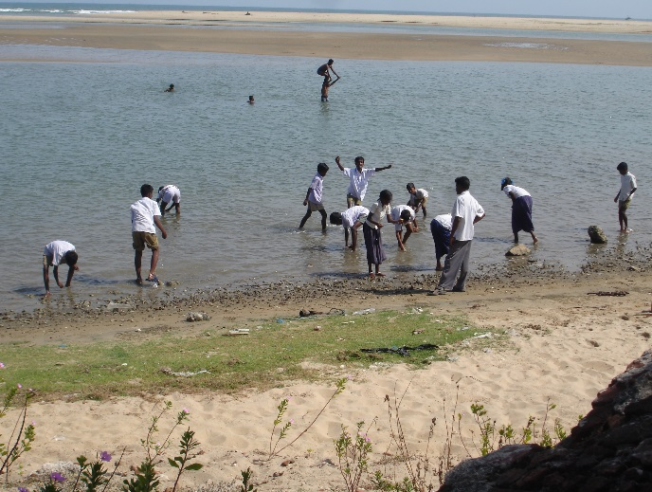
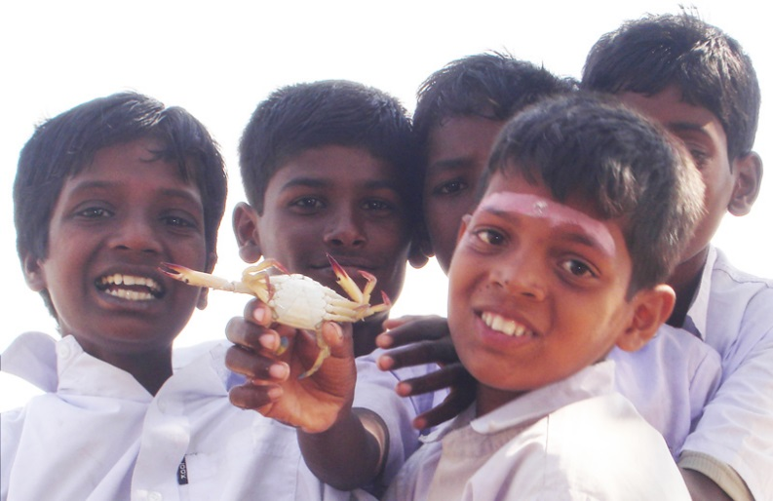
The natural environment is brought to the target groups through exhibits, interactive sessions, practical experiences, nature trails, nature games, etc., in a way which is interesting, pleasing and captivating. It is a classroom without the usual associated drudgery of books, lessons and standard written work.

The Nadukuppam Environmental Education Centre has been constructed at an existing Govt. school in the village of Nadukappam located in the Marakkanam taluk of the Villupuram district of Tamilnadu, about 40kms from Pondicherry. Pitchandikulam Forest already has an EE program in operation here. Nearby is a sizeable patch of forest land available for development and improvement. The centre is a focal point for community involvement in integrated rural planning and sustainable development. It is a research and teaching place for bringing biodiversity back to the land,
involving students and the communities of the Kaliveli bioregion. It is a demonstration site for sustainable technologies and ecological solutions.

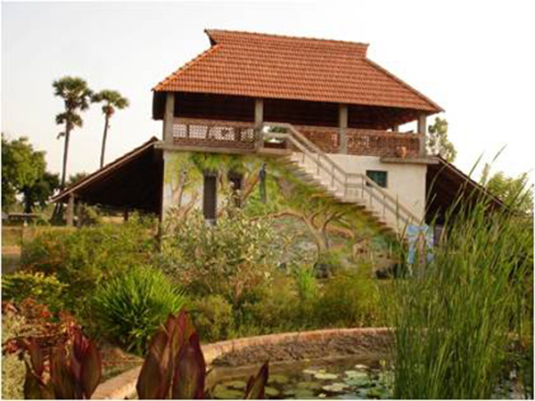
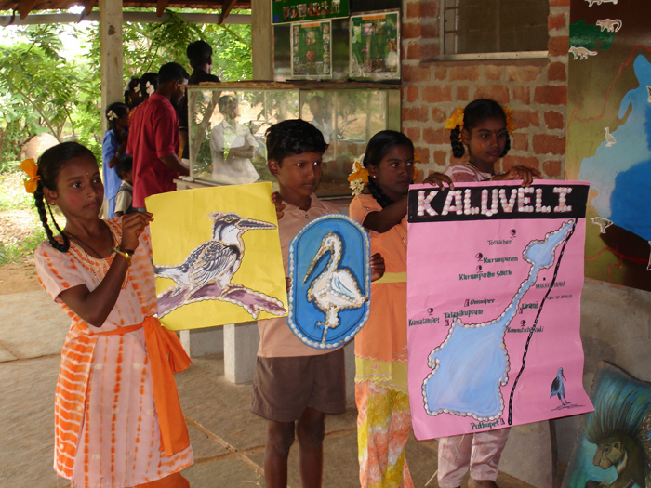
When the Pitchandikulam Forest began working with the Government High School at Nadukuppam to develop Environmental Awareness Programs in conjunction with the existing academic curriculum in 2003, the school’s academic pass rate was just 10%. There were only six teachers and five classrooms for 575 students and no water facilities or toilets and only two trees in the school compound. After adoption by Pitchandikulam Forest, a bore well, water tanks, hand pumps and drinking water systems have been installed and an organic vegetable garden has been developed. Two thousand indigenous trees have been planted within the school compound, a 3-acre ethno-medicinal forest has been established and solar photovoltaics powering water pumps have been installed. An integrated sanitation system for water recycling has been set up. Existing buildings have been improved, and the Education Department has built several new school buildings.

Currently 9 teachers conduct environmental education programs at Nadukuppam and at other schools in the area. Teaching is always outside of the classroom including programs such as children’s’ home medicinal plant gardens, street plantations, seed collections, bird watching and GIS resource mapping of the villages.

The Adyar Poonga is a sixty acre arm of the Adyar estuary in the cosmopolitan city of Chennai, Tamil Nadu which had fallen into total degradation due to indiscriminate dumping of raw sewage, garbage and construction debris for decades. The high pollution levels had destroyed most aquatic life there and created an unbearable stink for the residents around the wetland. A restoration project was proposed by the state government and handed over to the Pitchandikulam Forest Consultants for implementation. A year into the project has seen the waters cleaned, garbage removed, earth landscaped and native vegetation replanted, leading to the creation of a serene, clean habitat which is attracting the native wildlife back, something that is particularly visible in the aquatic animal life.

The Adyar Poonga has a strong EE thrust and has sought to embrace the residents and schools of the watershed of the Poonga into a stakeholders group to which EE is being delivered full-time. The Poonga is due to be opened in 2010 to the public when visitors will be able to enjoy a near-original clean, healthy, and conducive environmental situation once again.
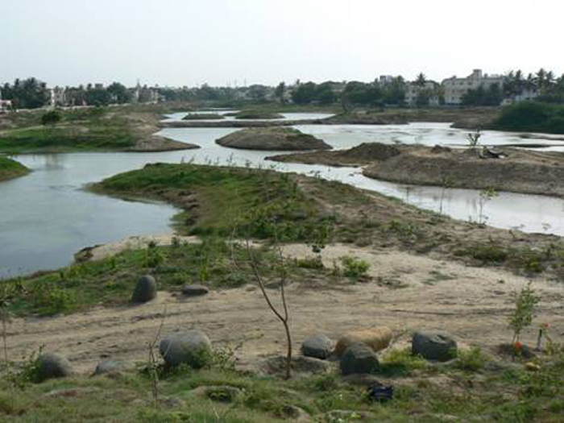
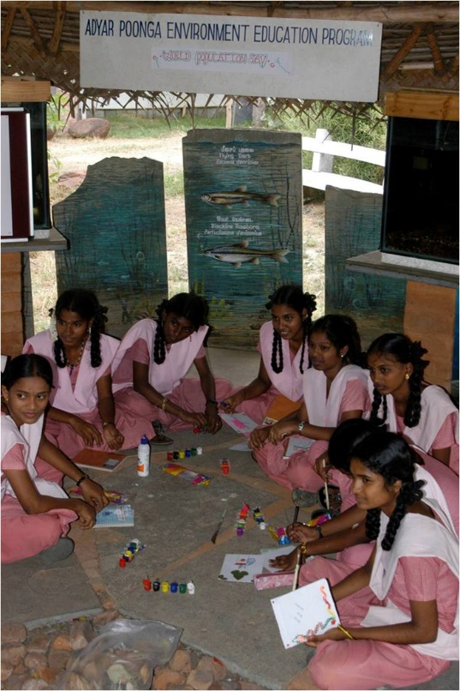

Objectives:

*To introduce the target groups to the beauty, complexity, fragility, resilience and importance of the natural world.

* To develop in the target groups, a sense of love and compassion for other living beings which have been on this planet longer than humans have.

* To create an interest in nature and natural habitats and to provide guidelines for nourishing this interest in the target groups.

* To disseminate knowledge about the rich natural heritage of the country.

* To make the Kadapakkam Environment Education Centre a model for practical coastal restoration ecology.

*To develop modules for training on coastal and inland ecosystems.

* To train members of the target groups on:
a) biodiversity and conservation of natural habitats.
b) sustainable utilization of habitats.
c) addressing environmental challenges including global warming.

Justification:

* The areas proposed for the EECs are located in rural and semi-rural surroundings where nature degradation has not reached the alarming proportions of cities. The people there are still relatively non-destructive in their ways but changes in lifestyle and habits are now making an appearance. The time is therefore right to enhance the awareness of these folk about the natural environment and the hazards it is facing from human activity along the coast and inland, and to inculcate in them the need for and importance of conservation of nature. Our children inherit the folly of their forebears, and are the hope of the future. They should have the opportunity and knowledge to make wise decisions about how to respect and live with good environmental principles. Hence, the program targets schools in the region.

* Earlier ecological and ethological values which were handed down for generations have become eroded in the march of development and these values need to be re-instated amongst the local folk.

* The coastline in the region is a long one, stretching for hundreds of kilometers to the southern tip of the country, but no properly conceptualized and organized EECs exist here. The need for such EECs is therefore pertinent and urgent.

* The Kadapakkam area is gaining popularity as a tourist spot. Unregulated and disorganized tourism can destroy a site or region, particularly its ecology. Training and instilling a conscience in the local communities about the importance and fragility of the ecosystem here would be a basic step towards protecting the environment from tourism-degradation.

* Being coastal, the Kadapakkam site could be hit by tsunamis or even normal sea erosion. The importance of tree-shelter belts and barriers to protect the coast from sea-erosion must form part of any education provided to the people of the area.

* Linking the three sites – Kadapakkam, Nadukuppam and Adyar Poonga – allows a healthy mix of knowledge and shared concerns. Kadapakkam has particular potential as a site for coastal ecosystem EE and will be used by groups from far and near.

Implementation:

* Developing and equipping the education and interpretation centre
a) Fauna and flora of the region will be displayed. Exhibits such as bones, scales, shells, feathers, abandoned nests, washed up material will be restored where possible and displayed in an interesting and informative manner. Collections of seeds, herbarium sheets and displays of indigenous plants used in traditional medicine will be exhibited.

b) Information and pictorial panels on various aspects of coastal ecosystems will be prepared on marine-ply for display.

c) Interactive items like rotating drums, flip-boards and light-assisted displays will be prepared and put on the exhibits.

d) Models of interesting animals / situations (like nesting cycle of sea turtles) will be built and displayed to replicate natural systems.

* Developing an EE program for schools

a) A program will be developed which will empower school children with knowledge about the subject and subsequent confidence in addressing related issues.

b) Informal classes will be conducted for educating students about their local environment, starting with flora and fauna and advancing to environmental issues.

c) Trails will be established through the nearby restored forest highlighting the coastal dry evergreen ecosystem.

d) Indoor hands-on sessions will be conducted where children will create models / items with an eco-connection or bearing like paper sculpture, origami, craft from waste, puppet making and story-creation, etc. Artwork using natural materials and local inspiration will be encouraged.

e) Debates and discussion programs will be conducted where children will be given real or simulated situations concerning the environment which they will discuss and try to find solutions for.

* Linking of the three centres

The Nadukuppam and Adyar Poonga centres will be linked to the Kadapakkam EEC enabling students from the three ecosystems to experience and appreciate the others as extension activities. Other groups too can experience this diversity.

* Development of modules

Four modules will be developed:
- Inventory of biodiversity of the area.
- Conservation of biodiversity and the ecosystem.
- Sustainable utilization of resources.
- Global concerns, particularly climate change.

These modules will be developed through the following route:
- Identification of users – who the modules will be used by
- Brainstorming with experts to identify the specific themes and details
- Structure of the module – what means will be used to create the module – book form, game-form, workshops, AVP, nature walk, etc.
- Collection of data – procurement of relevant material with which to produce the module
- Preparation of draft model – using the material procured, a prototype will be produced
- Field testing of prototype – the prototype will be field-tested to ensure desired impact and results
- Incorporation of results and finalizing the module
- Actual production of module in English and the local language

Production of these modules is important for replication and continuity as it lays down a path that can be followed by anyone so that functionality does not become dependent upon any one individual or group

Resource material

Visitor material – A folder will be prepared on certain relevant aspects of the concerned ecosystem along with selected checklists of relevant fauna and flora. A brief history of the centre as well as its proposed extension programs will be prepared and published for distribution

TT material - A booklet for use by teachers who will be carrying forward the work of EE to their students will be prepared for distribution to teachers who attend the TT workshops. The booklet will contain relevant notes on general ecology, the dangers the environment faces, nature conservation, selected relevant checklists, basic laws governing conservation, and a small “how-to” section which will inform on steps to be taken in case of a nature-related accident like snake-bite or scorpion-sting, sea and beach safety, reporting anti-environmental incidents like poaching, pollution, deforestation, etc., what to do with nature orphans or injured creatures, nature games, places of natural interest in the area, etc.

Student material – A work-book which will combine text with space for entering observations and notes will be produced for distribution to students attending the school workshops. The booklet will contain brief accounts of interesting aspects of nature existing in the area, do’s and don’ts for a healthy ecosystem, tips on saving electricity and water, hazards of plastic throw-away bags, a recording matrix for common wildlife of the area, sketch spaces, etc.

Material for other participants - This will be a small folder with short notes on general ecology, tips for a healthy environment, tips for saving water and electricity, hazards of plastic and encouraging its non-usage, recycling and re-use of everyday materials, being a green citizen, etc.

Output

  - A model Coastal Environment Centre practically useful for the community
  - Education modules which will be used to implement the project:
a) Inventory of biodiversity of the area
b) Conservation of biodiversity and the ecosystem
c) Sustainable utilization of resources
  - Development and production of resource materials for teachers, students, other workshop participants and visitors
  - Three thousand students, one hundred teachers, three hundred other participants and several hundred visitors are expected to visit the EEC each year.
  - Another 5000 students, 500 hundred teachers will be benefited indirectly by our outreach programs
  - Planting of 4 acres of indigenous coastal vegetation. 2000 plants of more than 100 species of the rare tropical dry evergreen forest ecosystem. 3000 life fencing plants of indigenous thorny species would be planted as a protective hedge.

Monitoring and Evaluation:

Feedback forms for teacher and student groups will be issued to all teachers and students who participate in workshops / camps organized for them. The forms will enable the surveyor to establish how much the participant has gained from the workshop / camp and what changes need to be incorporated into these activities to make them more effective and useful to the people and the environment. Follow-up visits to the schools of these teachers / students will be conducted to see if lessons learnt at the EEC activities have had the desired effect or whether suggestions / instructions issued have been followed. This would be followed by a revamping of activities at the EEC, if found desirable.
Pitchandikulam has developed EE centres and programs at Nadukuppam and Adyar Poonga. Kadapakkam will be developed into a coastal ecosystem campsite. Strong links are envisaged between the three sites.

